Multiples - Questions

Key Stage 2: 2003 Paper A
1.
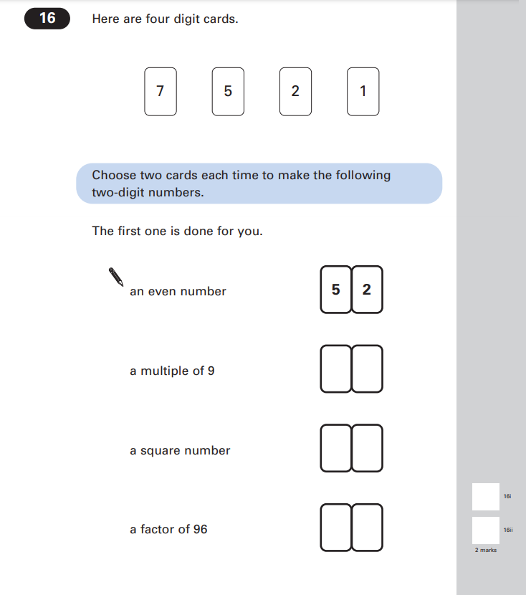
Key Stage 2: 2004 Paper B
1.
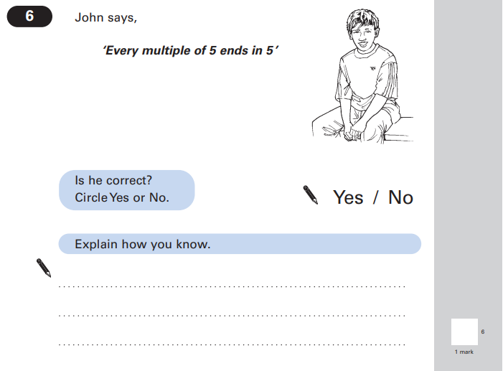
Key Stage 2: 2005 Paper A
1.
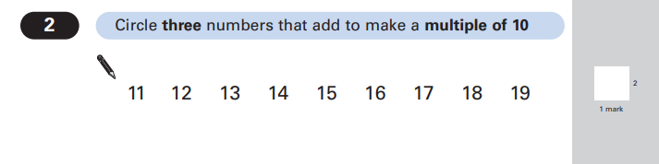

Key Stage 2: 2006 Paper B
1.
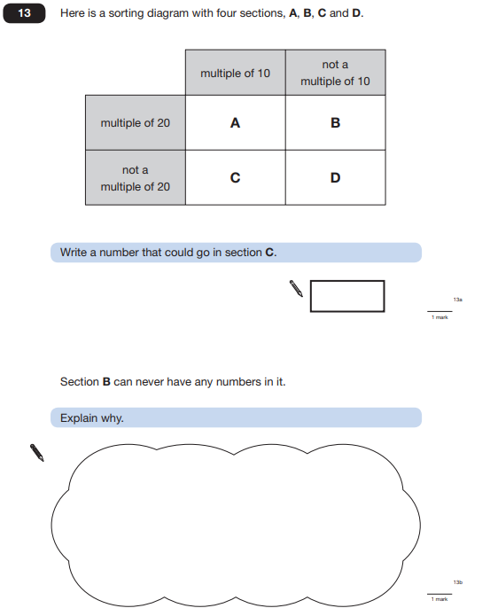

Key Stage 2: 2007 Paper A
1.
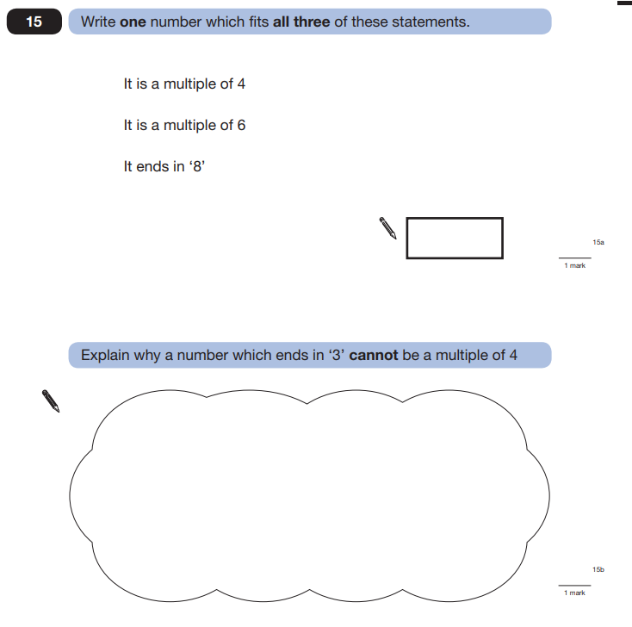

Key Stage 2: 2008 Paper B
1.
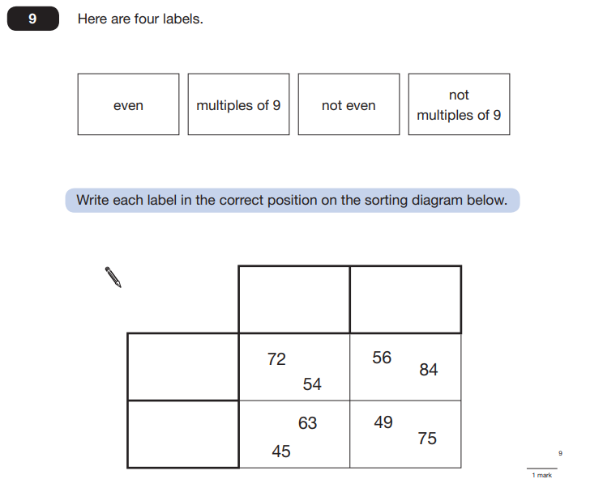

Key Stage 2: 2008 Paper B
2.
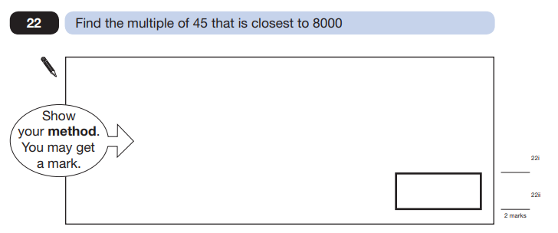

Key Stage 2: 2009 Paper A
1.
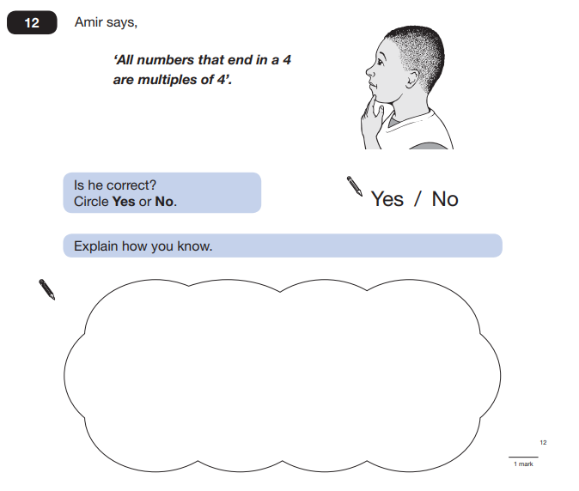

Key Stage 2: 2010 Paper B
1.
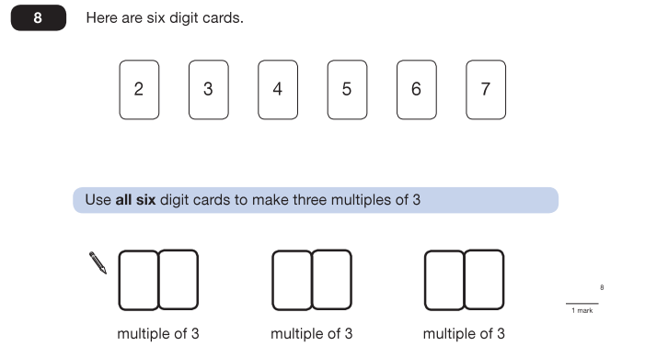

Key Stage 2: 2012 Paper A
1.
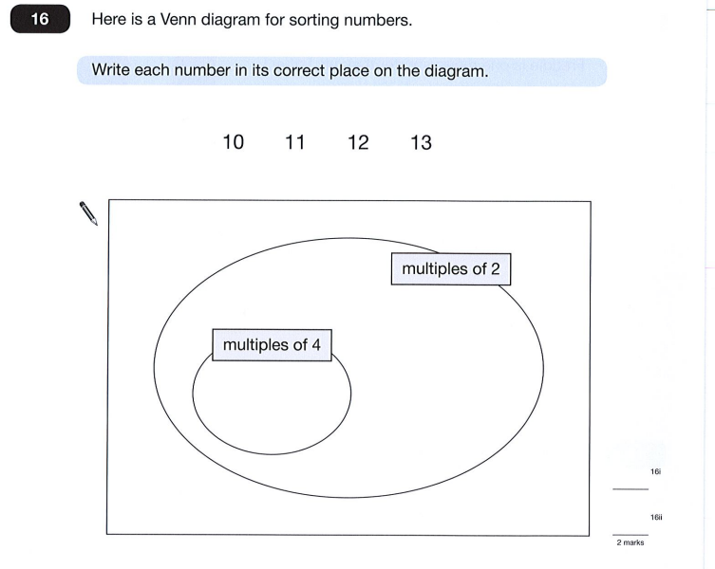

Key Stage 2: 2013 Paper B
1.
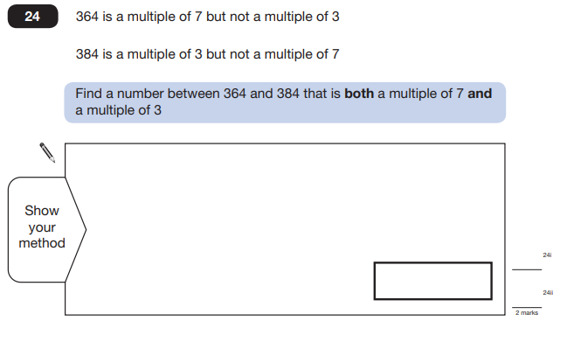

Key Stage 2: 2015 Paper B
1.
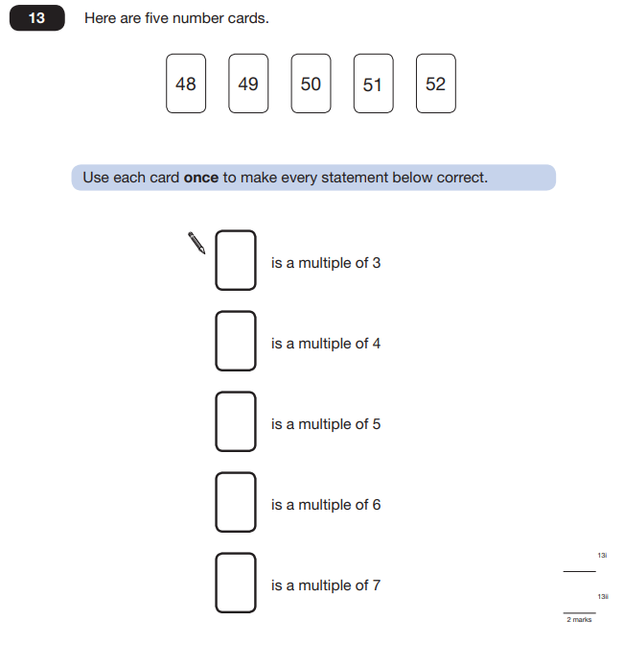

Key Stage 2: 2016 Paper 2 Reasoning - Sample
1.
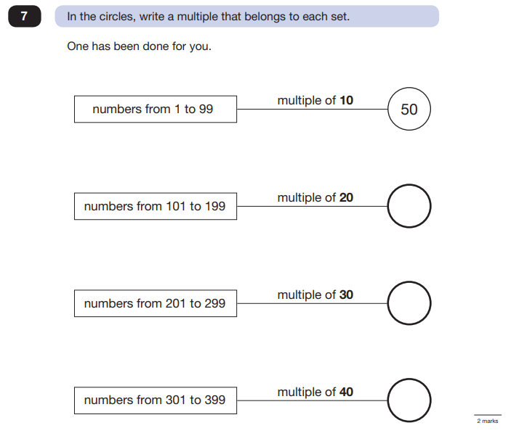

Key Stage 2: 2016 Paper 3 Reasoning - Sample
1.
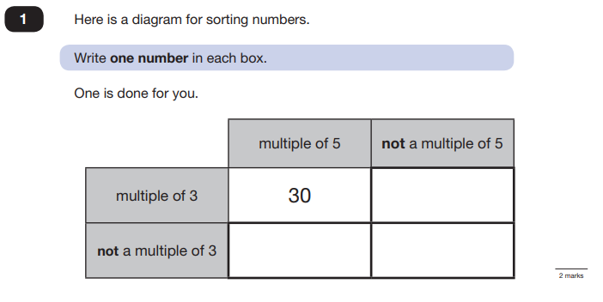
Key Stage 2: 2016 Paper 2 Reasoning
1.
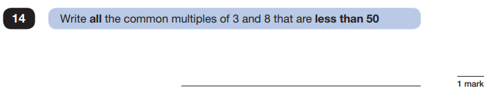

Key Stage 2: 2017 Paper 3 Reasoning
1.
